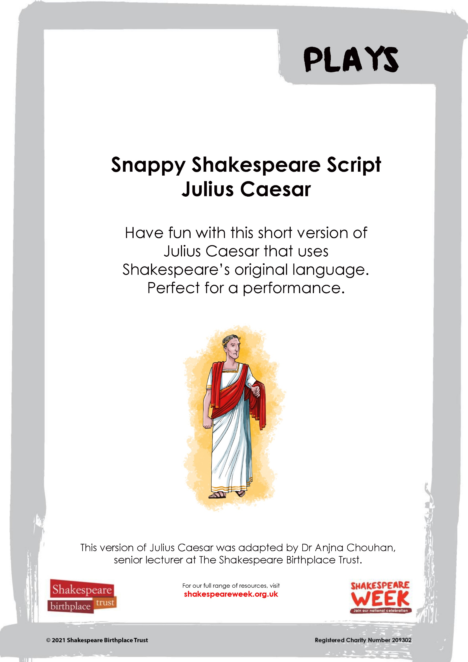

SNAPPY SHAKESPEARE: JULIUS CAESAR
JULIUS CAESAR
BRUTUS
CASSIUS
CASCA
MARK ANTONY
CALPURNIA
PORTIA
SOOTHSAYER
CINNA
DECIUS
PUBLIUS
OCTAVIUS

[Enter CEASAR, CALPURNIA, ANTONY, CASSIUS, BRUTUS, SOOTHSAYER]

CAESAR
Calpurnia!

CALPURNIA
Here, my lord.

CAESAR
Antony

ANTONY
Caesar, my lord?

Soothsayer
Caesar!

CAESAR
Ha! who calls?

Soothsayer
Beware the ides of March.

CAESAR
What man is that?

BRUTUS
A soothsayer bids you beware the ides of March.

CAESAR
Set him before me; let me see his face.

CASSIUS
Fellow, come from the throng; look upon Caesar.

CAESAR
What say'st thou to me now? speak once again.

SOOTHSAYER
Beware the ides of March.

CAESAR
He is a dreamer; let us leave him! Pass.

[Exit CEASAR, ANTONY, CALPURNIA one way and SOOTHSAYER another]
CASSIUS
Will you go see the order of the course?

BRUTUS
Not I.

CASSIUS
I pray you, do.

[shouts heard]

BRUTUS
What means this shouting? I do fear, the people Choose Caesar for their king.

CASSIUS
Ay, do you fear it?

BRUTUS
I love him well.

CASSIUS
Why, man, he doth bestride the narrow world
Like a Colossus.
The fault, dear Brutus, is not in our stars,
But in ourselves, that we are underlings.
BRUTUS
What you have said I will consider.
I will come home to you; or, if you will,
Come home to me, and I will wait for you.

CASSIUS
I will do so: till then, think of the world.

[Exit CASSIUS]

BRUTUS
It must be by his death.
And therefore think him as a serpent’s egg
Which, hatched, would, as his kind, grow mischievous,
And kill him in the shell.
[Knocking and enter CASSIUS, CASCA, DECIUS BRUTUS, CINNA, CIMBER]
CASSIUS
Good morrow, Brutus; do we trouble you?

BRUTUS
I have been up this hour, awake all night.
Know I these men that come along with you?

CASSIUS
Yes, every man of them,

CASSIUS
This, Decius Brutus.
CASSIUS
This, Casca; this, Cinna; and this, Metellus Cimber.

BRUTUS
They are all welcome.
Is not to-morrow the ides of March?

CINNA
Sir, March is wasted fourteen days.

DECIUS BRUTUS
Shall no man else be touched but only Caesar?

CASSIUS
Decius, well urged.

BRUTUS
Let us be sacrificers, but not butchers, Caius.
Let's carve him as a dish fit for the gods.

BRUTUS
Peace! count the clock.

CASSIUS
The clock hath stricken three.

CINNNA
’Tis time to part.

BRUTUS
And so good morrow to you every one.

[Enter PORTIA]
PORTIA
Brutus, my lord!

BRUTUS
Portia, what mean you? wherefore rise you now?

PORTIA
Dear my lord,
Tell me your counsels.
I have made strong proof of my constancy,
Giving myself a voluntary wound
Here, in the thigh: can I bear that with patience.
And not my husband's secrets?
BRUTUS
O ye gods,
Render me worthy of this noble wife!
Portia, let’s go in awhile.

[Exit BRUTUS and PORTIA]

[ENTER CEASAR and CALPURNIA]

CALPURNIA
What mean you, Caesar?
You shall not stir out of your house to-day.

CAESAR
Cowards die many times before their deaths;
The valiant never taste of death but once.

CALPURNIA
Do not go forth to-day.
Let me, upon my knee, prevail in this.

CAESAR
Well, for thy humour, I will stay at home.

[Enter DECIUS BRUTUS]
Here’s Decius Brutus, he shall tell them so.
DECIUS BRUTUS
Caesar, all hail! Good morrow, worthy Caesar:
I come to fetch you to the senate-house.

CAESAR
I will not come to-day: tell them so, Decius.

DECIUS BRUTUS
The senate have concluded
To give this day a crown to mighty Caesar.
If you shall send them word you will not come,
Their minds may change.
CAESAR
Give me my robe, for I will go.

[CAESAR puts on robe and CALPURNIA leaves]

[Enter SOOTHESAYER, CASSIUS, BRUTUS, CASCA, CINNA, CIMBER]

CAESAR
[To the Soothsayer] The ides of March are come.

SOOTHSAYER
Ay, Caesar; but not gone.

[Exit soothsayer]

CASCA
Speak, hands for me!
[CASCA stabs CEASAR, followed by the others, then BRUTUS last]
CAESAR
Et tu, Brute! Then fall, Caesar.
[Dies]
CINNA
Liberty! Freedom! Tyranny is dead!
Run hence, proclaim, cry it about the streets.

CASSIUS
Some to the common pulpits, and cry out
‘Liberty, freedom, and enfranchisement!’
BRUTUS
People and senators, be not affrighted.

CASSIUS
Where is Antony?

BRUTUS
But here comes Antony.
[Enter ANTONY]
Welcome, Mark Antony.

ANTONY [To Caesar’s body]
O mighty Caesar! dost thou lie so low?

CASSIUS
Mark Antony,--

ANTONY
Friends am I with you all and love you all,
May I produce his body to the market-place;
And in the pulpit, as becomes a friend,
Speak in the order of his funeral?

BRUTUS
You shall, Mark Antony. Here, take you Caesar's body.
You shall speak in the same pulpit,
After my speech is ended.

ANTONY
Be it so.

[Exit all except MARK ANTONY]

ANTONY
O, pardon me, thou bleeding piece of earth,
That I am meek and gentle with these butchers!

[He tends to the body, covering it carefully]

[Re-enter BRUTUS and others as CITIZENS. BRUTUS stands to give a speech to the Romans]

Citizens
We will be satisfied; let us be satisfied!

BRUTUS
Romans, countrymen, and lovers! As Caesar loved me, I weep for him; but, as he was ambitious, I slew him. There is tears for his love and death for his ambition!
Here is his body, mourned by Mark Antony.
[citizens start to cheer]
Good countrymen, let me depart alone,
And, for my sake, stay here with Antony.

Citizen
Let him go up into the public chair;
We’ll hear him. Noble Antony, go up.

[Everyone makes space around Antony and Caesar’s body]

ANTONY
Friends, Romans, countrymen, lend me your ears;
I come to bury Caesar, not to praise him.
The noble Brutus
Hath told you Caesar was ambitious.
He hath brought many captives home to Rome
Whose ransoms did the general coffers fill:
Did this in Caesar seem ambitious?
When that the poor have cried, Caesar hath wept:
Ambition should be made of sterner stuff:
Yet Brutus says he was ambitious;
And Brutus is an honourable man.
Look you here [He uncovers Caesar’s body]
Here is himself, marred, as you see, with traitors!

CITIZENS
We will be revenged!

[Exit citizens. Caesar’s body is carried off with them]

[Enter Octavius]

ANTONY
Octavius Caesar!

OCTAVIUS
Antony,
Brutus and Cassius
Are rid like madmen through the gates of Rome.

ANTONY
Octavius, lead your battle softly on, upon the left hand of the even field.

OCTAVIUS
Upon the right hand I; keep thou the left.

ANTONY
Why do you cross me in this exigent?

OCTAVIUS
I do not cross you; but I will do so.

[Exeunt to go to battle]

[Enter CASSIUS]

CASSIUS
O, coward that I am, to live so long,
To see my best friend taken before my face!
Guide thou the sword. [He stabs himself]
Caesar, thou art revenged,
Even with the sword that killed thee. [He dies]

[Enter Brutus]

BRUTUS
O Julius Caesar, thou art mighty yet!
Thy spirit walks abroad and turns our swords
In our own proper entrails.

[Enter Ghost of Caesar]

Ha! who comes here?
GHOST
Thy evil spirit, Brutus.

[Exit Ghost]

BRUTUS
I shall have glory by this losing day
More than Octavius and Mark Antony!
[stabs himself]

Caesar, now be still –
I killed not thee with half so good a will.

[Enter MARK ANTONY and OCTAVIUS CAESAR]

ANTONY
This was the noblest Roman of them all.

OCTAVIUS
So call the field to rest and let’s away,
To part the glories of this happy day.

END

